# Software System Architecture Document (SSAD)

**Healthy Kids Zone Survey App**

**Team 14**

|  |  |  |
| --- | --- | --- |
| **Name** | **Primary Role** | **Contact Email** |
| **Jessie Kim** | Client | JKim@chc-inc.org |
| **Joseph Martinez** | Client | JMartinez2@chc-inc.org |
| **Malcolm Carson** | Client | MCarson@chc-inc.org |
| **Yang Wang** | Project Manager | [wang195@usc.edu](mailto:wang195@usc.edu) |
| **Chad Honkofsky** | IIV&V/QFP | [honkofsk@usc.edu](mailto:honkofsk@usc.edu) |
| **Xu Zhang** | Builder (Front-end Designer) | [zhangxu@usc.edu](mailto:zhangxu@usc.edu) |
| **Chenglu Wang** | Tester | [wang358@usc.edu](mailto:wang358@usc.edu) |
| **Junjun Ji** | Builder (Mobile Designer) | [junjunji@usc.edu](mailto:junjunji@usc.edu) |
| **Ye Tao** | Builder (Back-end Designer) | [taoye@usc.edu](mailto:taoye@usc.edu) |

# Version History

| Date | Author | Version | Changes made | Rationale |
| --- | --- | --- | --- | --- |
| 10/16/2013 | Qianu Liao | 1.0 | * System Context Diagram | * Consolidated System Context Diagram to match OCD |
| 10/17/2013 | Qianyu Liao | 1.1 | * System Users Behavior | * Consolidated System Users Behavior to match OCD |
| 10/17/2013 | Qianyu Liao | 1.2 | * System Use Case | * Consolidated use cases to match OCD |
| 10/18/2013 | Qianyu Liao | 1.3 | * System Use Case | * Consolidated use cases to match OCD |
| 10/18/2013 | Qianyu Liao | 1.4 | * System Use Case | * Consolidated use cases to match OCD |
| 10/18/2013 | Qianyu Liao | 1.5 | * System physical architecture | * Consolidated use cases to match the clients requirement |
| 10/19/2013 | Qianyu Liao | 1.6 | * Add Survey Monkey to System Context Diagram | * Added System Context Diagram to match Client Requirement |
| 10/20/2013 | Qianyu Liao | 2.1 | * Reduce Use Case | * Reduced use cases to match ARB Review |
| 11/20/2013 | Qianyu Liao | 2.2 | * Modify use case, physical architecture | * Modified use cases and physical architecture to match DCR Review |
| 11/27/2013 | Qianyu Liao | 2.3 | * Rewrite the SSAD | * Rewrite the SSAD document to match the DCR Review and prepare for the development phase |
| 11/28/2013 | Qianyu Liao | 2.4 | * Modify Artifact and Information Diagram | * To satisfy the requirement |
| 12/09/2013 | Qianyu Liao | 2.5 | * Add the NDI/NCS evaluation part to SSAD | * To complete the whole SSAD |
| 02/09/2014 | Ye Tao | 3.0 | * Update Artifact and Information Diagram and System Behavior | * To comply with the system requirement |
| 02/17/2014 | Ye Tao | 3.1 | * Update Artifact and Information Diagram and System Behavior | * To comply with the system requirement |
| 04/02/2014 | Ye Tao | 3.2 | * Update diagrams and related explanations | * Follow TA’s instruction about fonts and notations |

# Table of Contents

Software System Architecture Document (SSAD) i

Version History ii

Table of Contents iii

Table of Tables iv

Table of Figures v

1. Introduction 1

1.1 Purpose of the SSAD 1

1.2 Status of the SSAD 1

2. System Analysis 2

2.1 System Analysis Overview 2

2.1.1 System Context 2

2.1.2 Artifacts and information 3

2.1.3 Behavior 5

3. NDI/NCS Interoperability Analysis 17

3.1 Introduction 17

3.1.1 COTS / GOTS / ROTS / Open Source / NCS 17

3.1.2 NDI/NCS Evaluation 17

3.2 System Structure 18

4. Class Design 22

4.1 Interface Classes 22

4.2 Process Realization 24

4.2.1 Render Survey Import Page 24

5. Architectural Styles, Patterns and Framework 26

# Table of Tables

Table 1: Context Summary 3

Table 2: Artifact and Information Summary 4

Table 3: Use Case Description 5

Table 4: Use Case Description 6

Table 5: Use Case Description 6

Table 6: Use Case Description 7

Table 7: Use Case Description 7

Table 8: Use Case Description 8

Table 9: Use Case Description 9

Table 10: Use Case Description 9

Table 11: Use Case Description 10

Table 12: Use Case Description 10

Table 13: Use Case Description 11

Table 14: Use Case Description 11

Table 15: Use Case Description 11

Table 16: Use Case Description 12

Table 17: Use Case Description 13

Table 18: Use Case Description 14

Table 19: Use Case Description 14

Table 20: Use Case Description 15

Table 21: Use Case Description 15

Table 22: Use Case Description 15

Table 23: Use Case Description 16

Table 24: NDI/NCS Product List 17

Table 25: Comparison of hybrid mobile app platform 17

Table 26: Comparison of survey application 18

Table 27: Hardware Component Description 19

Table 28: Software Component Description 20

Table 29: Design Class Description 22

Table 30: Architectural Styles, Patterns, and Frameworks 25

# Table of Figures

Figure 1: System Context Diagram 2

Figure 2: Artifact and Information Diagram 4

Figure 3: Process Diagram 5

Figure 4: Hardware component Diagram 19

Figure 5: Software component Diagram 20

Figure 6: Deployment Diagram 21

Figure 7: Design Class Diagram 22

Figure 8: Render Survey Import Page Sequence Diagram 23

Figure 9: Survey Import Sequence Diagram 24

### Introduction

#### Purpose of the SSAD

The purpose of the SSAD is to document the results of the object-oriented analysis and design (OOA&D) of the website being developed. The SSAD is used by the developer as reference to the system architecture. The website being developed should be faithful to the architecture specified in the SSAD. Furthermore, the SSAD is used by the maintainer and clients to help understand the structure of the system once the proposed website is delivered.

#### Status of the SSAD

The current version of the SSAD is 3.0 and it is at the end of the Rebaselined Foundation phase. At this point, all sections of the document are filled out with system context diagram, system behavior diagram, use case diagram, component diagram, deployment diagram, class diagram and sequence diagram. Team is actively exploring NDI, NCS and the selected architecture (3-tier architecture) and prototyping the system using it. Thus this document reflects current understanding of the developing system and the high risk features, and is an agreement with current prototype.

### System Analysis

#### System Analysis Overview

The primary purpose of Healthy Kids Zone Survey App is to map and assess physical assets and detriments to health as part of our initiative to reduce rates of obesity and hypertension in South Los Angeles. The Healthy Kids Zone Survey App System allows administrator to import the survey from survey monkey application (the administrator should create the survey on the survey monkey first), configure the connection between school, path and survey, and then the administrator could export the survey results. The Healthy Kids Zone Survey App System allows user take survey on their mobile app easily. Figure 1 is the System Context Diagram. Table 1 is the diagram summary.

##### System Context

##### Macintosh HD:Users:Tony:Downloads:Use Case Diagram4.png

Figure 1: System Context Diagram

Table 1: Context Summary

| **Actor** | **Description** | **Responsibilities** |
| --- | --- | --- |
| Healthy Kids Zone Survey System | The new system our team will build | * The website system will be used by administrator to import survey, configure the connection between schools, paths and surveys, and export survey results * The mobile app system will be used by uses to take survey easily |
| Administrator | People who use the Healthy Kids Zone website system and manage the system. | * Import survey from survey monkey * Configure the connection between school, path and survey * Export the survey results |
| User | People who use the Healthy Kids Zone survey app to take survey | * Take survey |
| Survey Monkey | An application that the administrator could create survey  An API that the website system could retrieve the surveys list and details | * Create survey * Retrieve survey details |
| Google Maps | An API that the administrator could draw the path coordinates  An API that the users could add markers and comments | * Draw path coordinates * Add markers and comments |

##### 

##### Artifacts and information

Figure 2 illustrates the data structure of our system.

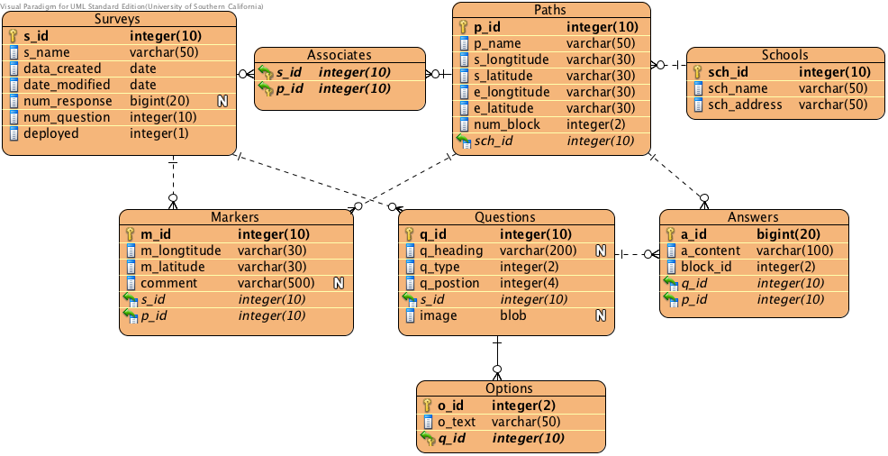

Figure 2: Artifact and Information Diagram

Table 2: Artifact and Information Summary

|  |  |
| --- | --- |
| **Artifact** | **Purpose** |
| ATF-1: School | School information the administrator adds through the website |
| ATF-2: Path | Path coordinates the administrator selects on the Google Map |
| ATF-3: Survey | General information about survey which is retrieved from Survey Monkey API |
| ATF-4: Associate | Based on our requirements, one survey can be used in many paths; one path can contain many surveys. They are many-to-many relationship, so we generate a new table to store the relations. |
| ATF-5: Question | Question information in the survey which is retrieved from Survey Monkey |
| ATF-6: Option | Option information of multiple choice question in the survey which is retrieved from survey monkey |
| ATF-7: Answer | Answer information sent from mobile application. |
| ATF-8: Marker | To store markers that our app system provide |

##### Behavior

Figure 3 illustrates the behaviors of users and administrators.

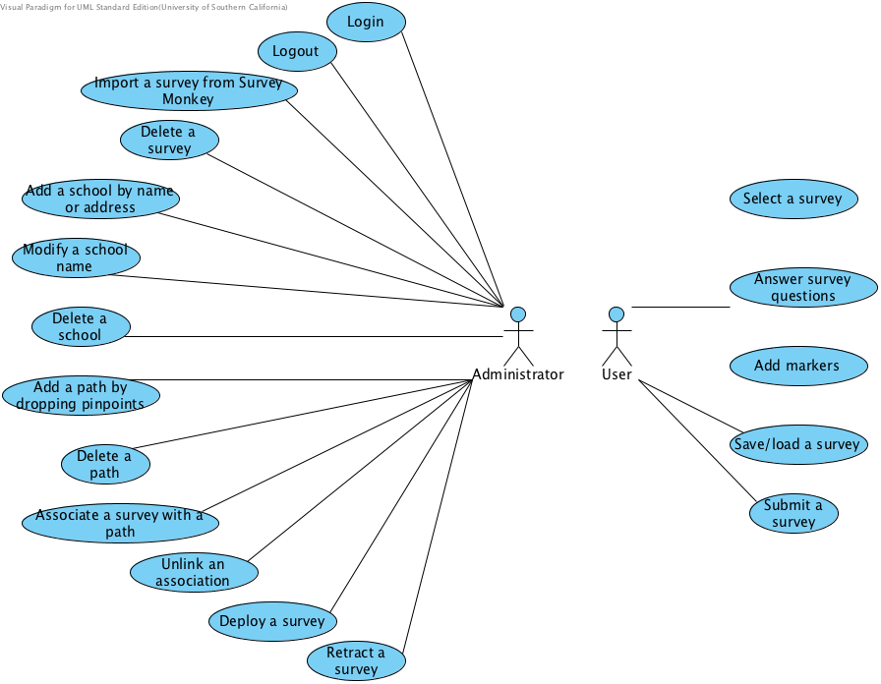

Figure 3: Process Diagram

###### Administrator use cases

Table 3: Use Case Description

|  |  |  |  |
| --- | --- | --- | --- |
| **Identifier** | UC-1: Main page | | |
| **Pre-conditions** | Administrator is logged into the system. | | |
| **Post-conditions** | Administrator is logged out of the system. | | |
| **Typical Course of Action** |  | Actor Input | System Response |
| 1 | Administrator clicks logout button |  |
| 2 |  | System logs user out and redirects him to HKZ login page |

Table 4: Use Case Description

|  |  |  |  |
| --- | --- | --- | --- |
| **Identifier** | UC-2-1: Administrator imports a survey. | | |
| **Pre-conditions** | Administrator is logged into the system.  The system shows the survey import page. | | |
| **Post-conditions** | The survey detail is retrieved from Survey Monkey and inserted into the database. | | |
| **Typical Course of Action** |  | Actor Input | System Response |
| 1 |  | Load survey list from API and DB and display the survey import page |
| 2 | User click the import button of a survey |  |
| 3 |  | Retrieve the survey detail from Survey Monkey, check it and insert data to database |
| **Exceptional Course of Action** | 1 | User is going to import an invalid survey (Mal-formatted survey, survey missing critical information or survey with unsupported questions) |  |
| 2 |  | Retrieve the survey detail from Survey Monkey check it and prompt an error message |

Table 5: Use Case Description

|  |  |  |  |
| --- | --- | --- | --- |
| **Identifier** | UC-2-2: Administrator deletes a survey. | | |
| **Pre-conditions** | Administrator is logged into the system.  The system shows the survey deletion page. | | |
| **Post-conditions** | The survey and all related answers are deleted from the database. | | |
| **Typical Course of Action -1** |  | Actor Input | System Response |
| 1 |  | Load survey list from database and display survey deletion page |
| 2 | User click the delete button of a survey |  |
| 3 |  | Check the database whether there are answers under this survey. If so, prompt a confirm message to the administrator that it is an irreversible operation |
| 4 | User click confirm button |  |
| 5 |  | Delete the survey from database |
| **Typical Course of Action -2** | 4 | User click cancel button |  |
| 5 |  | Return to the survey deletion page |
| **Exceptional Course of Action** | 1 |  | If there is no answer under the survey to be deleted, delete the survey without confirmation |

Table 6: Use Case Description

|  |  |  |  |
| --- | --- | --- | --- |
| **Identifier** | UC-3-1: Administrator adds a school. | | |
| **Pre-conditions** | Administrator is logged into the system.  The system shows the school adding page. | | |
| **Post-conditions** | A school (including school name, address and location information) is added and inserted into the database. | | |
| **Typical Course of Action** |  | Actor Input | System Response |
| 1 |  | Display the school adding page |
| 2 | User types in the school name and address and then click add button |  |
| 3 |  | Retrieve the school information from the database. Check if there is a school with the same name and address. If not, insert the school name and address into the database. |
| **Exceptional Course of Action** | 1 |  | If there is a school with the same name and address in the database, prompt an alert that the school is already in the database. |

Table 7: Use Case Description

|  |  |  |  |
| --- | --- | --- | --- |
| **Identifier** | UC-3-2: Administrator deletes a school. | | |
| **Pre-conditions** | Administrator is logged into the system.  The system shows the school deletion page. | | |
| **Post-conditions** | The school and all related answers are deleted from the database. | | |
| **Typical Course of Action** |  | Actor Input | System Response |
| 1 |  | Load school list from the database and display the school deletion page |
| 2 | User clicks the delete button of a school |  |
| 3 |  | Check the database whether there are answers under this school. If so, prompt a confirm message to the administrator that it is an irreversible operation |
| 4 | User clicks confirm button |  |
| 5 |  | Delete the school from the database |
| **Typical Course of Action -2** | 4 | User click cancel button |  |
| 5 |  | Return to the school deletion page |
| **Exceptional Course of Action** | 1 |  | If there is no answer under the school to be deleted, delete the school without confirmation |

Table 8: Use Case Description

|  |  |  |  |
| --- | --- | --- | --- |
| **Identifier** | UC-3-3: Administrator modifies a school name. | | |
| **Pre-conditions** | Administrator is logged into the system.  The system shows the school modify page. | | |
| **Post-conditions** | The school name is modified in the database. | | |
| **Typical Course of Action** |  | Actor Input | System Response |
| 1 |  | Load school list from the database and display the school modify list including school name and address |
| 2 | User select a school and types in the school name and then click add button |  |
| 3 |  | Update the school name in the database |

Table 9: Use Case Description

|  |  |  |  |
| --- | --- | --- | --- |
| **Identifier** | UC-4-1: Administrator adds a path. | | |
| **Pre-conditions** | Administrator is logged into the system.  The system shows the path adding page. | | |
| **Post-conditions** | The selected path is inserted into the database. | | |
| **Typical Course of Action** |  | Actor Input | System Response |
| 1 |  | Load school list from the database and display the school list, a text box for path name and a map |
| 2 | Select one of the schools |  |
| 3 |  | Pin location of the school in the map |
| 4 | Drop a starting point and an ending point in the map, type in path name and click confirm |  |
| 5 |  | Insert the information of path name and location to database |

Table 10: Use Case Description

|  |  |  |  |
| --- | --- | --- | --- |
| **Identifier** | UC-4-2: Administrator deletes a path. | | |
| **Pre-conditions** | Administrator is logged into the system.  The system shows the path deletion page. | | |
| **Post-conditions** | The selected path is deleted from the database. | | |
| **Typical Course of Action** |  | Actor Input | System Response |
| 1 |  | Load school list from the database and display the path deletion page |
| 2 | Selects a school from the list. |  |
| 3 |  | Load path list from the database and display path list related to the selected school. |
| 4 | Clicks the delete button of a path |  |
| 5 |  | Check the database whether there are answers under this path. If so, prompt a confirm message to the administrator that it is an irreversible operation |
| 6 | Clicks confirm button |  |
| 7 |  | Delete the path and answers related to the path from the database. |
| **Exceptional Course of Action** | 1 |  | If there is no answer under the path to be deleted, delete the path without confirmation |

Table 11: Use Case Description

|  |  |  |  |
| --- | --- | --- | --- |
| **Identifier** | UC-5-1: Administrator associates a path with a survey. | | |
| **Pre-conditions** | Administrator is logged into the system.  The system shows the association page. | | |
| **Post-conditions** | The selected path is associated with the selected path and the association is inserted into the database. | | |
| **Typical Course of Action** |  | Actor Input | System Response |
| 1 |  | Load survey list and school list from the database and display the association page |
| 2 | Select survey name and school name from the lists. |  |
| 3 |  | Load path list from the database |
| 4 | Select path name from the list and click associate button. |  |
| 5 |  | Check if there is already an association between the path and the survey. If not, insert an association to the database |

Table 12: Use Case Description

|  |  |  |  |
| --- | --- | --- | --- |
| **Identifier** | UC-5-2: Administrator unlinks an association. | | |
| **Pre-conditions** | Administrator is logged into the system.  The system shows the association page. | | |
| **Post-conditions** | The association is deleted from the database. | | |
| **Typical Course of Action** |  | Actor Input | System Response |
| 1 |  | Load association list from the database and display the association deletion page |
| 2 | Select an association from the list and click unlink |  |
| 3 |  | Delete the association from the database |

Table 13: Use Case Description

|  |  |  |  |
| --- | --- | --- | --- |
| **Identifier** | UC-6-1: Administrator deploys a survey. | | |
| **Pre-conditions** | Administrator is logged into the system.  The system shows the survey deployment page. | | |
| **Post-conditions** | The survey is marked deployed in the database. | | |
| **Typical Course of Action** |  | Actor Input | System Response |
| 1 |  | Load survey list from the database and display the survey deployment page |
| 2 | User click the deploy button of a survey |  |
| 3 |  | Update the survey to deployed in the database. |

Table 14: Use Case Description

|  |  |  |  |
| --- | --- | --- | --- |
| **Identifier** | UC-6-2: Administrator retracts a survey. | | |
| **Pre-conditions** | Administrator is logged into the system.  The system shows the survey deployment page. | | |
| **Post-conditions** | The survey is marked undeployed in the database. | | |
| **Typical Course of Action** |  | Actor Input | System Response |
| 1 |  | Load survey list from the database and display the survey deployment page |
| 2 | User click the retract button of a survey |  |
| 3 |  | Update the survey to undeployed in the database. |

Table 15: Use Case Description

|  |  |  |  |
| --- | --- | --- | --- |
| **Identifier** | UC-7: Administrator exports a survey. | | |
| **Pre-conditions** | Administrator is logged into the system.  The system shows the survey export page. | | |
| **Post-conditions** | The selected survey information is export into a csv format file. | | |
| **Typical Course of Action** |  | Actor Input | System Response |
| 1 |  | Load survey list from the database and display the survey export page |
| 2 | User click the export button of a survey |  |
| 3 |  | Retrieve the survey detail from the database. Construct a survey report containing all the answers grouped by location information in csv format |
| **Exceptional Course of Action** | 1 |  | 1 stands for yes, and 0 stands for no. Missing information should be marked as -9 in the report |

###### Mobile user use cases

Table 16: Use Case Description

|  |  |  |  |
| --- | --- | --- | --- |
| **Identifier** | UC-8: User starts a new survey. | | |
| **Pre-conditions** | The application shows the application homepage. | | |
| **Post-conditions** | Information of the selected survey is retrieved from the database and system jumps into a question category page of the selected survey. | | |
| **Typical Course of Action** |  | Actor Input | System Response |
| 1 | User click the new survey button |  |
| 2 |  | Send request and retrieve school, path and survey list from the server and display a school list |
| 3 | Select a school in the list |  |
|  | 4 |  | Display a path list of the selected school |
|  | 5 | Select a path in the list |  |
|  | 6 |  | Display a survey list with surveys associated with the selected path |
|  | 7 | Select a survey in the list |  |
|  | 8 |  | Send request and retrieve the selected survey from the server and display a category page with a question list |

Table 17: Use Case Description

|  |  |  |  |
| --- | --- | --- | --- |
| **Identifier** | UC-9-1: User answers survey questions. | | |
| **Pre-conditions** | The application shows the question page. | | |
| **Post-conditions** | The answer to the question is stored in temporary storage on the phone, waiting to be submitted. | | |
| **Typical Course of Action -1** |  | Actor Input | System Response |
| 1 |  | Displays a question with multiple choice (single answer) |
| 2 | Clicks one of the answers. |  |
| 3 |  | The answer appears chosen.  Updates the answer in the temporary storage file. |
| **Typical Course of Action -2** | 1 |  | Displays a question with multiple choice (multiple answer) |
| 2 | Clicks a collection of the answers |  |
| 3 |  | The answers are chosen.  Updates the answer in the temporary storage file |
| **Typical Course of Action -3** | 1 |  | Displays a comment question with an edit box |
| 2 | Types in comments in the edit box |  |
| 3 |  | Updates the answer in the temporary storage file |
| **Typical Course of Action -4** | 1 |  | Displays a tally question with a number, a plus and a minus mark |
| 2 | Clicks on plus or minus |  |
| 3 |  | Updates the answer in the temporary storage file |
| **Exceptional Course of Action -1** | 1 | Click the function bar |  |
| 2 |  | Display a function menu including show map, save, quit without saving and submit |
| 3 | Click one of these choices |  |
| 4 |  | Jump to execute corresponding feature |
| **Exceptional Course of Action -2** | 1 | Click category button |  |
| 2 |  | Jump to question category list |

Table 18: Use Case Description

|  |  |  |  |
| --- | --- | --- | --- |
| **Identifier** | UC-9-2: User navigates in the category list. | | |
| **Pre-conditions** | The system shows a question category list of the selected survey. | | |
| **Post-conditions** | The system jumps into the selected question page. | | |
| **Typical Course of Action** |  | Actor Input | System Response |
| 1 |  | Display a question category list |
| 2 | Click a question type (Block/Tally/Other) |  |
| 3 |  | Display a question list of selected question type |
| 4 | Click a question in the list |  |
| 5 |  | Jump into question page of the selected question |

Table 19: Use Case Description

|  |  |  |  |
| --- | --- | --- | --- |
| **Identifier** | UC-10: User adds a marker. | | |
| **Pre-conditions** | The system shows a map of the selected path. | | |
| **Post-conditions** | Marker location and comments are inserted into database. | | |
| **Typical Course of Action** |  | Actor Input | System Response |
| 1 |  | Display a map of the selected path |
| 2 | Right click on the map to create a marker |  |
| 3 |  | Display a comment box over the map |
| 4 | Type in comments with respect to the marker (For example, report some hazard) |  |
| 5 |  | Send the comment text to the server and the server insert data into the database |
| **Exceptional Course of Action** | 1 | User types in comment over 500 characters. |  |
| 2 |  | Display an error message that character number is over-limited |

Table 20: Use Case Description

|  |  |  |  |
| --- | --- | --- | --- |
| **Identifier** | UC-11-1: User saves a survey to the mobile device. | | |
| **Pre-conditions** | The system shows a function menu in question or category page. | | |
| **Post-conditions** | Answers to the ongoing survey are stored in the mobile device. | | |
| **Typical Course of Action** |  | Actor Input | System Response |
| 1 | User clicks the save button in function menu |  |
| 2 |  | Store the temporary file to app storage. |
| **Exceptional Course of Action** | 1 | The mobile device is out of available space. |  |
| 2 |  | Display an error message that the device does not have enough space. |

Table 21: Use Case Description

|  |  |  |  |
| --- | --- | --- | --- |
| **Identifier** | UC-11-2: User loads an existing survey from the mobile device. | | |
| **Pre-conditions** | The system shows the application homepage. | | |
| **Post-conditions** | Survey answers and questions are retrieved from local storage of the mobile device and the system shows a question page. | | |
| **Typical Course of Action** |  | Actor Input | System Response |
| 1 | User clicks the load survey button in homepage |  |
| 2 |  | Load and continue a survey from record file in app storage. Jump to question category page. |
| **Exceptional Course of Action** | 1 | There is no existing survey saved in the device. |  |
| 2 |  | Display an error message that no saved survey is found. |

Table 22: Use Case Description

|  |  |  |  |
| --- | --- | --- | --- |
| **Identifier** | UC-12-1: User submits a survey. | | |
| **Pre-conditions** | The system shows a function menu in question or category page. | | |
| **Post-conditions** | The survey answers are submitted to the server and inserted into the database. | | |
| **Typical Course of Action** |  | Actor Input | System Response |
| 1 | User clicks the submit button in function menu |  |
| 2 |  | Check whether all the questions are answered. If so, send the answer to the server. The server inserts the answer into the database. |
| **Exceptional Course of Action** | 1 |  | If some of the answers are unanswered, prompt a message that finish the survey first and then try again. |

Table 23: Use Case Description

|  |  |  |  |
| --- | --- | --- | --- |
| **Identifier** | UC-12-2: User relinquishes a survey. | | |
| **Pre-conditions** | The system shows a function menu in question or category page. | | |
| **Post-conditions** | The survey answers are deleted and the system returns to the application homepage. | | |
| **Typical Course of Action** |  | Actor Input | System Response |
| 1 | User clicks the quit without saving button in function menu |  |
| 2 |  | Display a confirmation that it will delete all the answers and quit. |
| 3 | Click confirm button. |  |
| 4 |  | Delete the temporary file and return to the homepage. |

### NDI/NCS Interoperability Analysis

#### Introduction

In this project, Healthy Kids Zone Survey App will retrieve the survey detail info from Survey Monkey API and use Google Map to define the path for the survey.

##### COTS / GOTS / ROTS / Open Source / NCS

Table 24: NDI/NCS Product List

|  |  |
| --- | --- |
| **NDI/NCS Products** | **Purposes** |
| Survey Monkey | Help administrator to create survey  Retrieve survey detail info from Survey Monkey API |
| PhoneGap / JQuery Mobile | A framework to develop a hybrid mobile app |
| Google Map | Administrator can define the path coordinates on the map  User can add markers and comments on the map |
| MySQL | To store survey data |
| Apache web server | Such as, provide different languages compiling, font-end and back-end communication, data transmission service |

##### NDI/NCS Evaluation

Table 25: Comparison of hybrid mobile app platform

|  |  |  |
| --- | --- | --- |
| **NDI/NCS** | **Pros** | **Cons** |
| Titanium | 1. Rapid prototyping; 2. Native UI; 3. native app performance, we did the tab transition prototype comparison with other platform to prove that; 4. accessible to device features, we did the taking picture prototype to prove it; | 1. Only compatible with Android and IOS and BlackBerry. However, our clients only require us to develop the mobile app based on the android platform |
| PhoneGap | 1. Rapid testing and deployment; 2. Access basic native functionality; 3. Relatively flat learning curve. | 1. Poor performance especially in the automation, transition and tabs change. , we proved it by prototyping. Basically, it need 0.5 minute more than Titanium); |
| Sencha Touch | 1. Mainly based on Ext JS, cool UI; 2. Good performance. | 1. Relatively steep learning curve if you don't have a good background knowledge with JavaScript 2. Sench Touch IDE is a paid application. We did not have enough budgets to pay for that; |

Table 26: Comparison of survey application

|  |  |  |
| --- | --- | --- |
| **NDI/NCS** | **Pros** | **Cons** |
| Survey Monkey | 1. Our clients have bought the Survey Monkey already. | 1. We need to create the tally type of question by ourselves. |
| Qualtrics | 1. Qualtrics supports more than 200 types of questions, includes the tally type. 2. Qualtrics has mobile Qualtrics version, so we might only need to put a little efforts on building the UI of the mobile app | 1. Qualtrics is a paid application, and we do not have budgets to afford that; |

#### System Structure

Figure 4,5 and 6 illustrate the system structure.

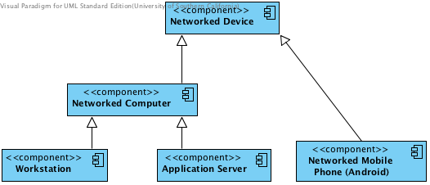

Figure 4: Hardware component Diagram

Table 27: Hardware Component Description

|  |  |
| --- | --- |
| **Hardware Component** | **Description** |
| Networked Computer | A computer that is connected to other networked computers through the internet. In our system, every computer will be networked in this manner. |
| Application Server | A networked computer which provides applications to workstations. In our system, this will be the server our software will be deployed on. |
| Workstation | A networked computer which is used to access services on the internet. In our system, this will be a computer used by people at home or in an office to interact with the timeline application server. |
| Networked Mobile Phone | A [mobile phone](http://en.wikipedia.org/wiki/Mobile_phone) built on a [mobile operating system](http://en.wikipedia.org/wiki/Mobile_operating_system), with more advanced computing capability and connectivity than a [feature phone](http://en.wikipedia.org/wiki/Feature_phone) |
| Networked Device | The device supporting the system to work, such as a router |

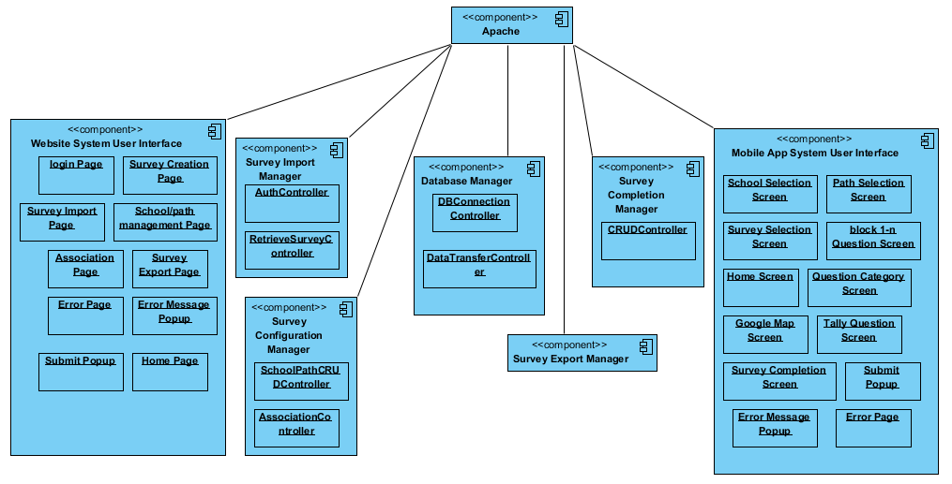

Figure 5: Software component Diagram

Table 28: Software Component Description

|  |  |
| --- | --- |
| **Software Component** | **Description** |
| Website User Interface | The HTML and PHP pages and forms that users of the system interact with directly |
| Survey Import Manager | The part of the system that used to retrieve survey detail from survey monkey and then import survey |
| Survey Configuration Manager | Manage the school and paths, such as, add, delete, modify, create, and associate the connection between school, path and surveys |
| Database Manager | Control the database connection |
| Survey Export Manager | Export the survey results by CSV file format |
| Survey Completion Manager | Loading schools, paths, surveys from database and then insert the survey results to database, help users to complete the survey. |
| Mobile App System User Interface | The HTML and JS pages and forms that users of the system interact with directly |
| Apache | Such as, provide different languages compiling, font-end and back-end communication, data transmission service |

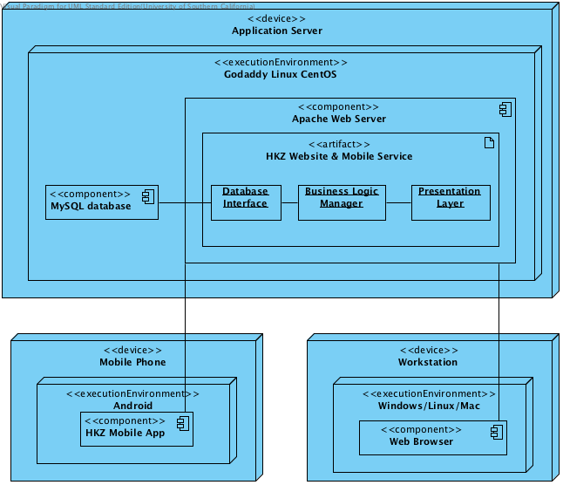

Figure 6: Deployment Diagram

### Class Design

#### Interface Classes

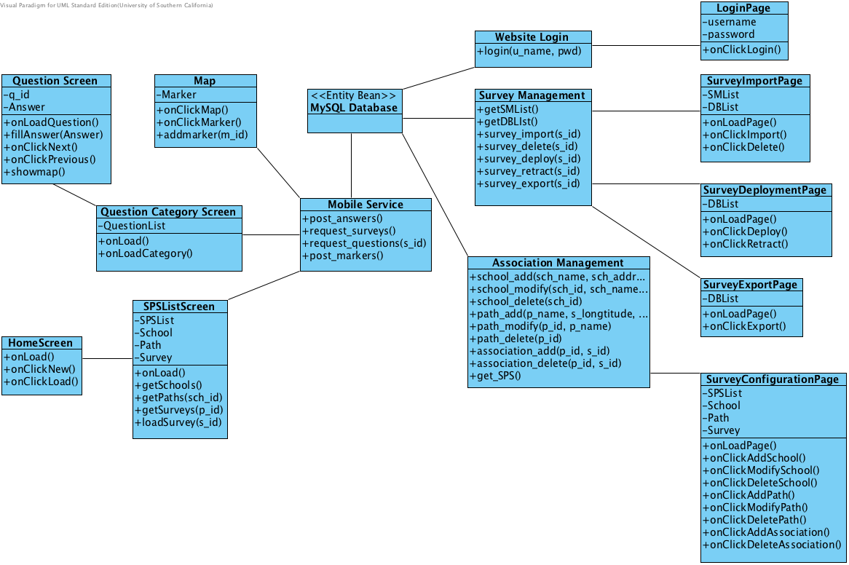

Figure 7: Design Class Diagram

Table 29: Design Class Description

|  |  |  |
| --- | --- | --- |
| **Class** | **Type** | **Description** |
| **Home page** | **Boundary** | **Main page of the website system** |
| **Login page** | **Boundary** | **Page with a login form** |
| **Survey creation page** | **Boundary** | **Page that redirect user to survey monkey.com** |
| **Survey import page** | **Boundary** | **Page that import survey** |
| **School and path management page** | **Boundary** | **Page that administrator could add/delete/modify school and path** |
| **Associate connection page** | **Boundary** | **Page that administrator could associate the connection between school, path and survey** |
| **Survey export page** | **Boundary** | **Page that administrator could export survey results** |
| **School selection screen** | **Boundary** | **Screen that user can select a school** |
| **Path selection screen** | **Boundary** | **Screen that user can select a path** |
| **Survey selection screen** | **Boundary** | **Screen that user can select a survey** |
| **Question category screen** | **Boundary** | **Screen that user can view all the question type** |
| **Block 1-n question screen** | **Boundary** | **Screen that user answer the question for each block** |
| **Tally question screen** | **Boundary** | **Screen that user answer the question of tally type** |
| **Home screen** | **Boundary** | **Main page of the mobile app system** |
| **Google Map screen** | **Boundary** | **Screen that user can see the path of the survey and add marker/comment to the map** |
| **Survey completion screen** | **Boundary** | **Screen that user submit the survey successfully** |

#### Process Realization

The Process Realization diagrams show sequences for the most risky use cases. These are the use cases that, if implemented wrong, would cause the whole system or major parts of it to fail or at least to not work as expected (as opposed to those use cases whose faulty implementation would be contained to themselves).

##### Render Survey Import Page

This shows the administrator need to import survey from survey monkey and db, which is what our capability of whole survey creation process to administrator rests on.

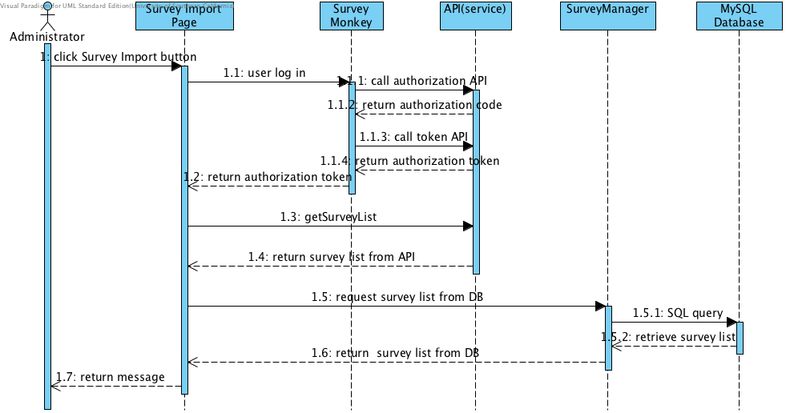

Figure 10: Render Survey Import Page Sequence Diagram

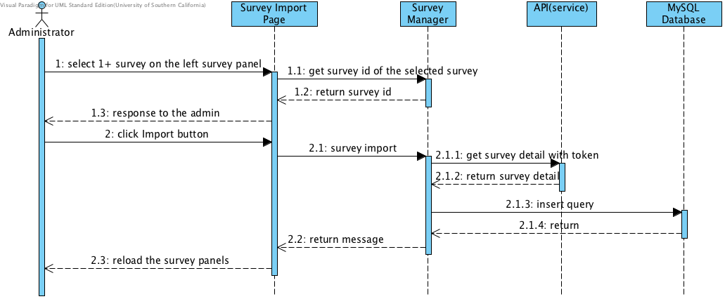

Figure 11: Survey Import Sequence Diagram

### Architectural Styles, Patterns and Framework

Table 30: Architectural Styles, Patterns, and Frameworks

|  |  |  |
| --- | --- | --- |
| Name | Description | Benefits, Costs, and Limitations |
| Three-tier  Architecture | Three-tier architecture is an architectural style and a design pattern that separates the presentation of data, business logic and the data itself into tiers that, in the case of our system, reside on two different systems and are managed with three different applications:   * All data is presented within web browsers on networked machines that will in most cases be offsite. * The business logic platform will be Apache running on Linux CentOS * The data will be managed using a MySQL database running on Linux CentOS on the same virtual machine as Apache (this is based on the setup of the physical system) | Benefits:   * Individual tiers can be modified independently from the rest of the system without breaking it (less coupled than a monolithic architecture) * Enforces separation of data, business logic and presentation on the developers, thereby making them create code that is more easily maintained because its functionality is more easily understood due to its impact being more localized within the system.   Cost:   * There is no specific cost required. * Limitations: Potential limited speed losses when data which is transferred between the browser and the database and vice versa has to pass through the separate business layer and has to be replicated in the database and the servlet container |